SIMATS ENGINEERING

ASSESSMENT TOOL 1

COURSE NAME: Database Management Systems COURSE CODE: CSA0504

COURSE OUTCOME COVERED

CO2: Apply the relational model, relational algebra, SQL query structures, and views to solve database querying and data manipulation problems. (BL3, BL6)

Activity Tool : Analytical Problem Solving (High) Assessment Tool Weightage: 40%

QUESTIONS
Q.N  o | Question | Bloom's Level
1 | Given a set of relations and sample data, write SQL queries to retrieve specific information using joins and subqueries, and explain the logic used.  Bloom’s Level: BL3 – Apply | BL4 – Analyze
2 | Using relational algebra, formulate expressions to solve complex queries such as retrieving records that satisfy multiple conditions across relations.  Bloom’s Level: BL4 – Analyse | BL5 – Evaluate
3 | Given a real-world scenario (e.g., banking or student system), design a relational schema and construct appropriate SQL queries for data retrieval and updates. Bloom’s Level: BL6 – Create | BL6 – Create
4 | Analyse a given SQL query with nested subqueries and predict its output, explaining each step of execution.  Bloom’s Level: BL4 – Analyze | BL6 – Create
5 | Compare different SQL approaches (joins vs subqueries) for solving the same problem and evaluate their efficiency. Bloom’s Level: BL5 – Evaluate | BL4 – Analyze
6 | Design and implement views for a database system to provide restricted data access, and justify their use for security and abstraction.  Bloom’s Level: BL6 – Create | BL5 – Evaluate
7 | Given a database schema, write relational algebra expressions and convert them into equivalent SQL queries, analyzing differences in representation.  Bloom’s Level: BL4 – Analyze | BL4 – Analyze

8 | Optimize a set of inefficient SQL queries by restructuring them using joins, indexing concepts, or views, and evaluate performance improvements.  Bloom’s Level: BL5 – Evaluate | BL5 – Evaluate
9 | Develop a complex SQL query involving grouping, aggregation, and nested queries to solve a real-world problem.  Bloom’s Level: BL6 – Create | BL6 – Create
10 | Given multiple relations, analyze the query requirements and decide whether to use views, joins, or subqueries, justifying your choice with reasoning.  Bloom’s Level: BL5 – Evaluate | BL5 – Evaluate

Code of Conduct:

I Geferlin Boffy R (192571080) certify that this submission is my original work and that I have adhered to the guidelines specified for this assessment. I understand that any violation of academic integrity rules will result in disciplinary action.
Signature of the student:

ANSWERS
- SQL Queries Using Joins and Subqueries

TABLE DEPARTMENT:
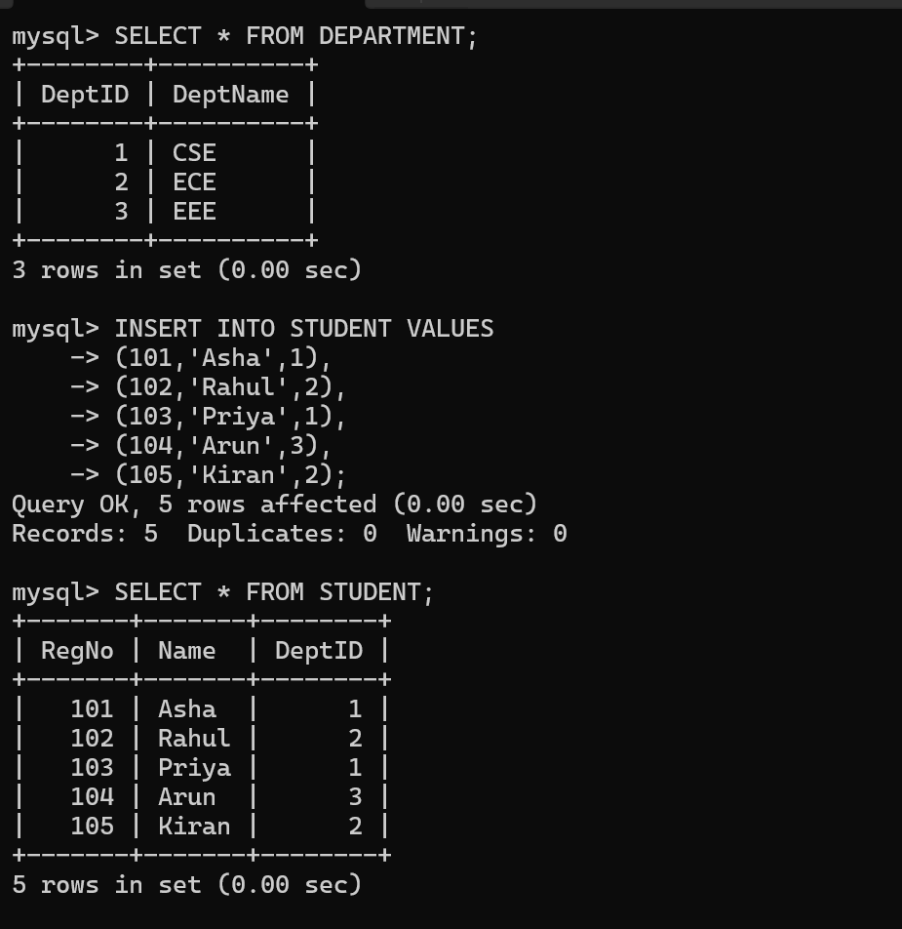
TABLE STUDENT:


JOIN QUERY:
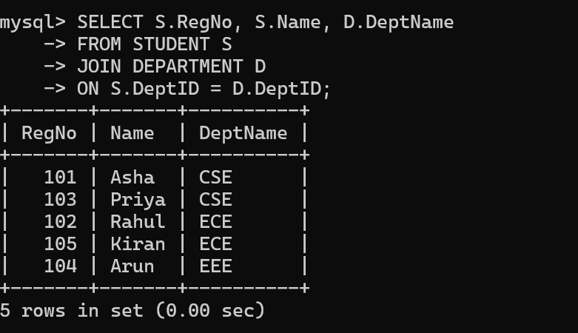
Logic
- JOIN combines rows from both tables.
- Matching is done using DeptID.

SUBQUERY:
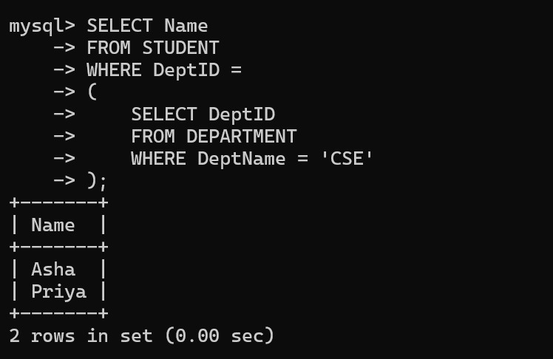
Logic
- Inner query finds CSE department ID.
- Outer query retrieves students belonging to that depart

2) Relational Algebra Expressions
Relations:
STUDENT(RegNo, Name, DeptID)
DEPARTMENT(DeptID, DeptName)
Query 1: Retrieve all students who belong to the CSE department.
Relational Algebra:
STUDENT ⋈ STUDENT.DeptID = DEPARTMENT.DeptID DEPARTMENT
σ DeptName = 'CSE'
(STUDENT ⋈ STUDENT.DeptID = DEPARTMENT.DeptID DEPARTMENT)

Query 2: Retrieve the names of students in the CSE department.
Relational Algebra:
π Name
(
σ DeptName = 'CSE'
(STUDENT ⋈ STUDENT.DeptID = DEPARTMENT.DeptID DEPARTMENT)
)

Query 3: Retrieve RegNo and Name of students in the CSE department.
Relational Algebra:
π RegNo, Name
(
σ DeptName = 'CSE'
(STUDENT ⋈ STUDENT.DeptID = DEPARTMENT.DeptID DEPARTMENT)
)

3)Design Relational Schema

Table ACCOUNT:
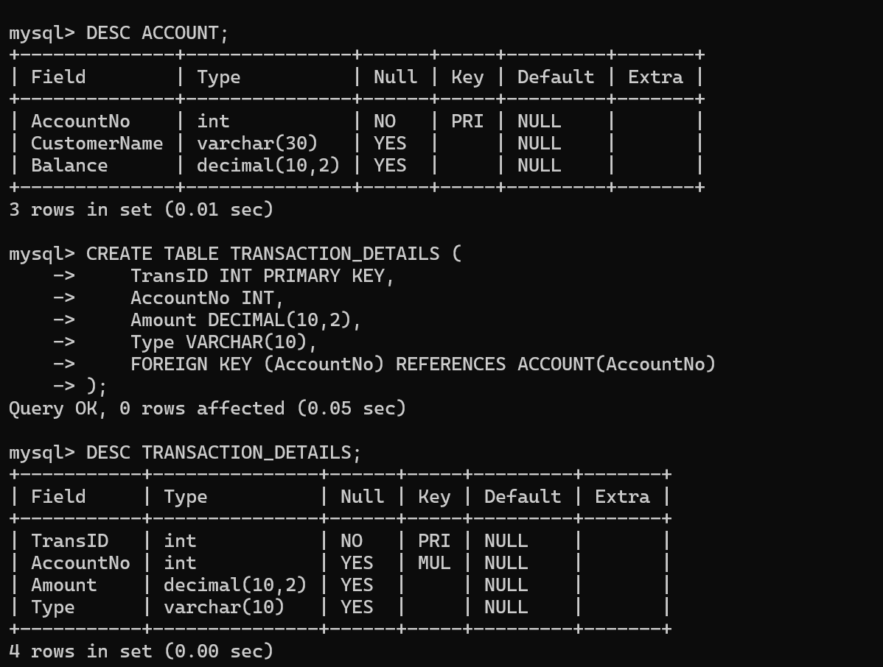

Table TRANSACTION_DETAILS:


Sample account details:
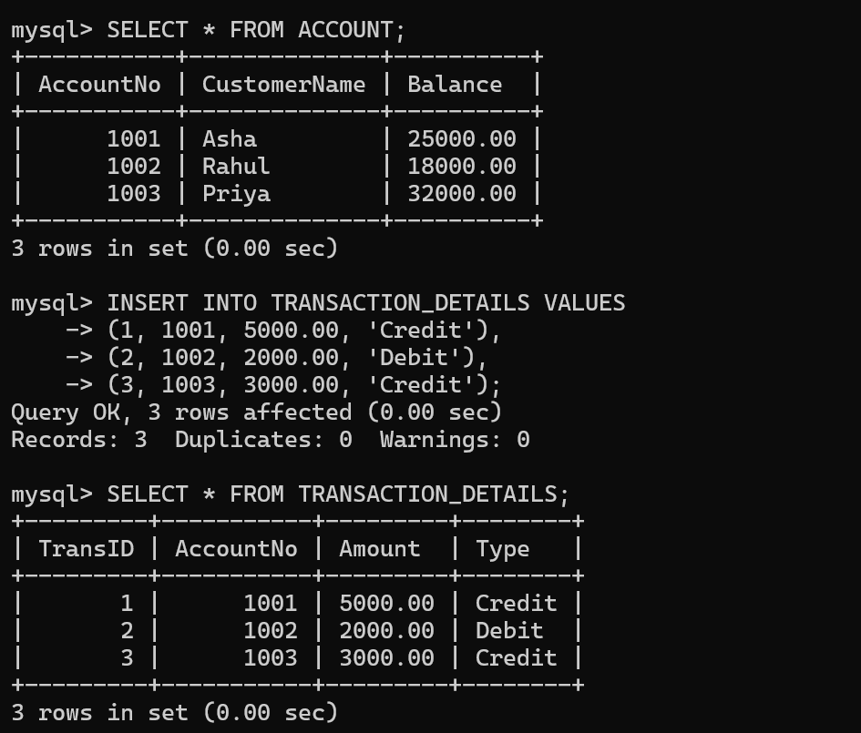

Transaction Records:


AccountNo 1001 now has the updated balance e.g., 30000.00:
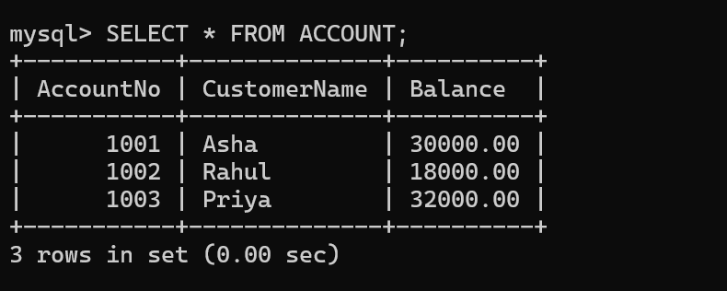

4) Nested Subqueries

TABLES OF DEPARTMENT:
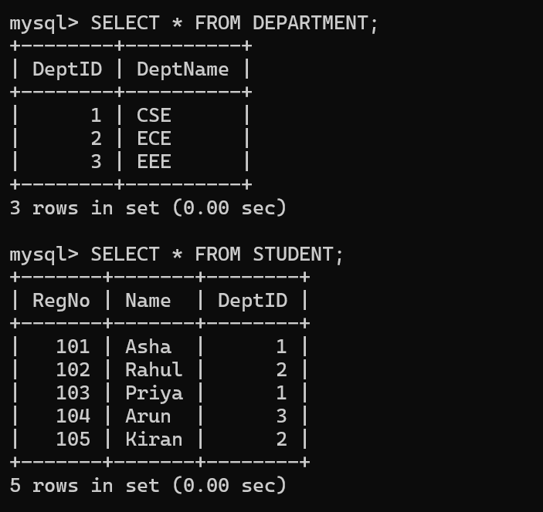

Output of the nested subquery:
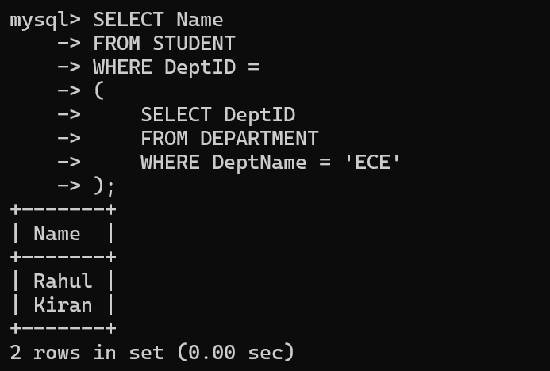

Inner Query:
SELECT DeptID
FROM DEPARTMENT
WHERE DeptName='ECE';
Output: DeptID = 2

Outer Query:
SELECT Name
FROM STUDENT
WHERE DeptID = 2;
Final Output:
- Rahul
- Kiran

5) Joins vs Subqueries

SOLVED USING JOIN:
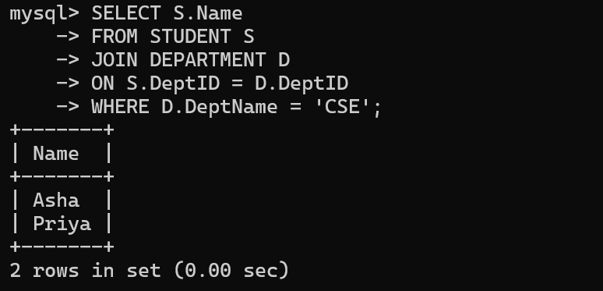

SOLVED USING SUBQUERY:
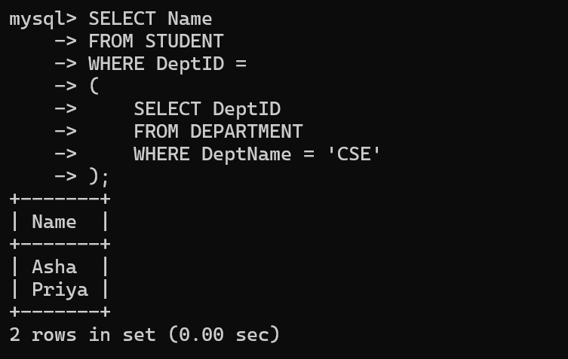

JOIN | Subquery
Combines tables directly | Uses one query inside another
Usually faster | May be slower
Better for multiple tables | Good for simple lookups
Preferred for large datasets | Easier for simple filtering
Conclusion
JOIN is generally more efficient than a subquery because it retrieves data by combining tables directly, making it faster for large datasets. Subqueries are simpler for filtering based on the result of another query.

6) Implementation of Database Views
Creating a VIEW:
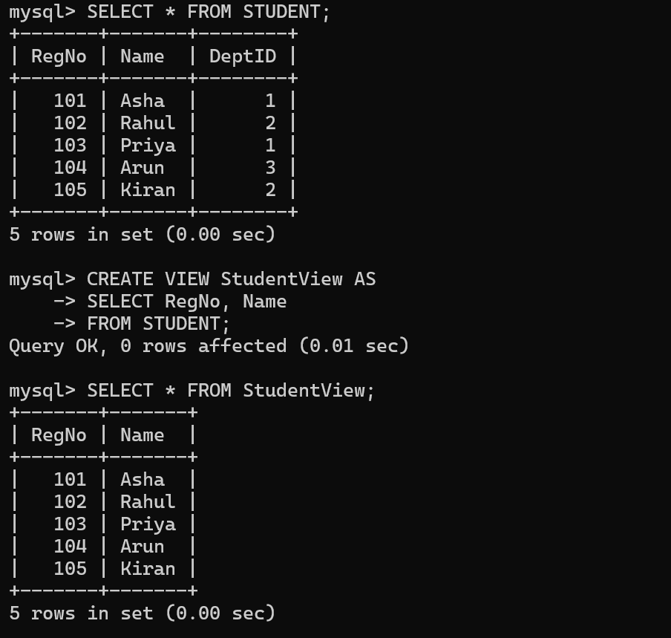

Display the VIEW:


Uses of Views:
- Provides security by hiding sensitive columns.
- Simplifies complex SQL queries.
- Provides data abstraction.
- Allows users to access only the required data.

7) Relational Algebra and SQL

Database Schema
STUDENT(RegNo, Name, DeptID)
DEPARTMENT(DeptID, DeptName)

Relational Algebra Expression
π Name
(
σ DeptName = 'CSE'
(STUDENT ⋈ STUDENT.DeptID = DEPARTMENT.DeptID DEPARTMENT)
)

Equivalent SQL Query
SELECT S.Name
FROM STUDENT S
JOIN DEPARTMENT D
ON S.DeptID = D.DeptID
WHERE D.DeptName = 'CSE';

Output of the SQL query
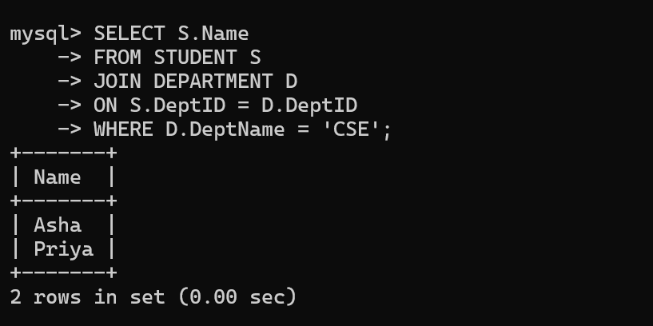

Difference between Relational Algebra and SQL
Relational Algebra | SQL
Theoretical query language | Practical query language
Uses symbols (σ, π, ⋈) | Uses SQL keywords (SELECT, FROM, JOIN)
Describes what operation to perform | Used to execute queries on the database

8) SQL Query Optimization

Inefficient Query (Using Subquery):
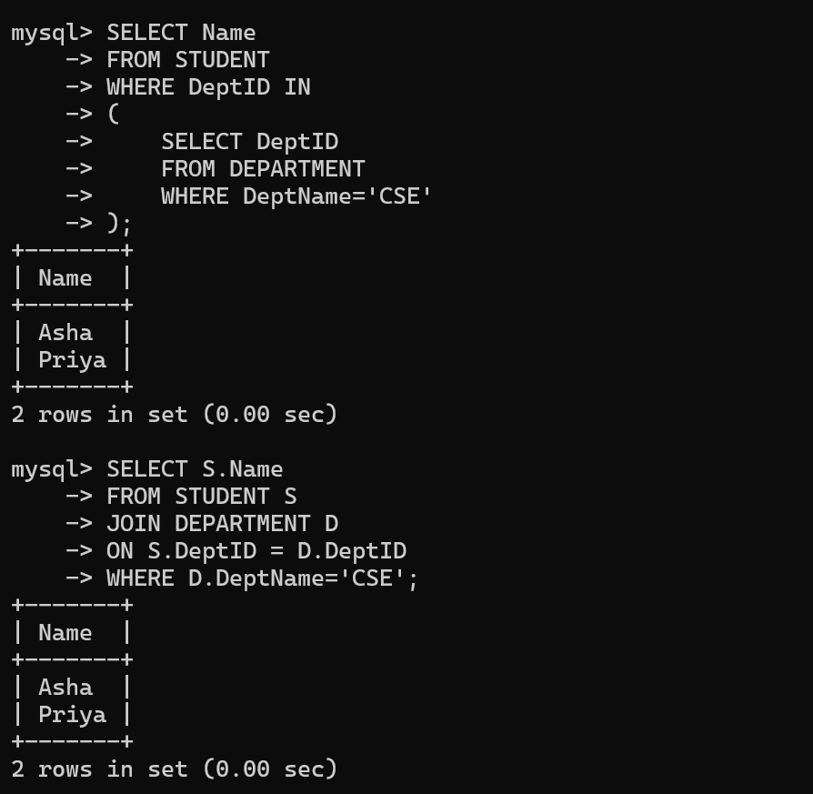

Optimized Query (Using JOIN):


Indexing

CREATE INDEX idx_deptid
ON STUDENT(DeptID);

Explanation:
- An index speeds up searching based on DeptID.
- It improves query performance by reducing the time needed to locate matching rows.

PERFOMNCE EVALUATION
Inefficient Query | Optimized Query
Uses a subquery | Uses JOIN
May execute more slowly | Generally faster
Harder for large datasets | Better for large datasets
Less efficient | More efficient

Conclusion
The JOIN-based query is generally more efficient than the subquery because it combines related tables directly. Creating an index on DeptID further improves performance by allowing MySQL to find matching records more quickly.

9) Grouping, Aggregation and Nested Queries

GRUPING QUERY:
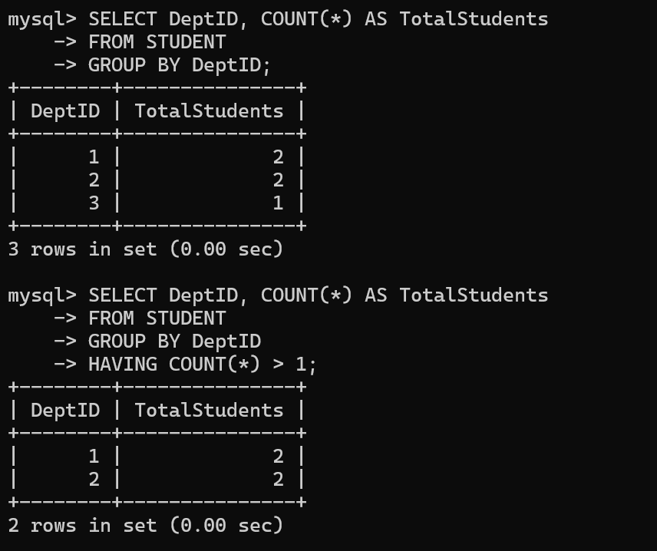

Aggregation with HAVING:


NESTED QUERY:
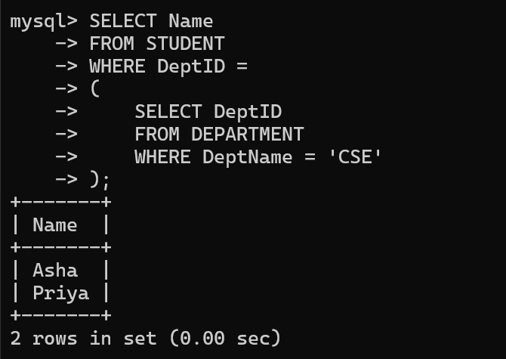

- GROUP BY groups rows based on DeptID.
- COUNT() counts the number of students in each department.
- HAVING filters grouped results.
- Nested Query retrieves students from the CSE department using the result of another query.

10) Views, Joins and Subqueries
JOIN Query:
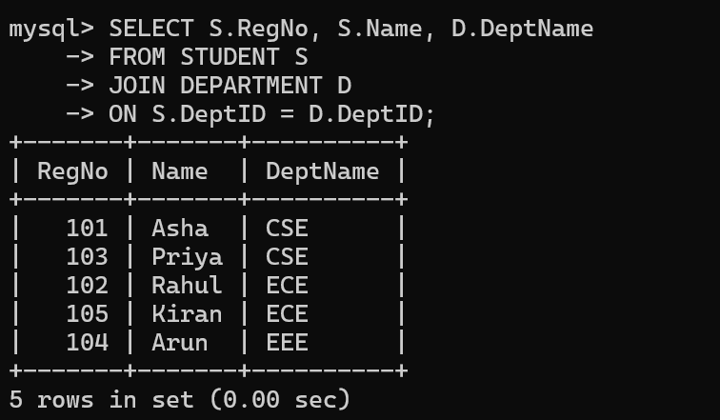

SubQuery:
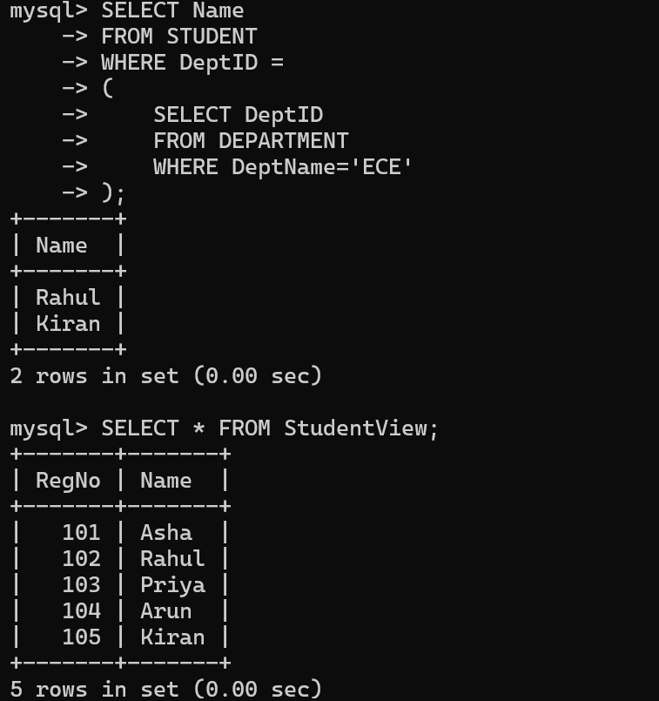

View:


JUSTIFICATION

Requirement | Best Choice | Reason
Retrieve related data from multiple tables | JOIN | Efficiently combines related tables.
Find records based on another query | Subquery | Useful when one query depends on another.
Restrict user access to selected columns | VIEW | Provides security and data abstraction.

Conclusion:
JOIN is the best choice when data must be retrieved from multiple related tables. Subqueries are useful when one query depends on the result of another query. Views are best for restricting access to selected columns and simplifying frequently used queries.

